

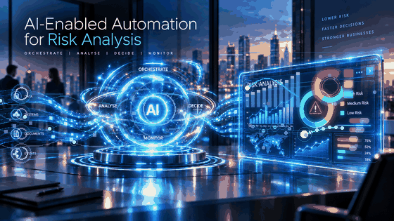
Lab-3

Powered by

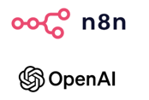

Learning Objectives

This lab will help you understand and apply a practical Agentic AI orchestration approach for transaction-risk assessment. You will learn how outputs from multiple specialist AI Agents can be consolidated, evaluated, and transformed into an overall risk recommendation and management-level output.

Getting familiar with the n8n workflow automation environment

- Understand the role of an AI Orchestrator in a multi-agent workflow.
- Consolidate the risk assessment reports generated by Agent-1, Agent-2, and Agent-3 for orchestration and final risk assessment.
- Configure the final Agentic AI Orchestrator to evaluate specialist findings and determine an overall customer risk assessment.
- Apply orchestration logic to generate an overall risk level, risk score, key red flags, and recommended action.
- Use Structured Output to produce a consistent consolidated risk result.
- Generate a consolidated customer risk output and management dashboard.
- Understand how Human-in-the-Loop, and explainability support responsible decision-making for higher-risk cases.

Task | Lab 3 Flow – Agentic AI Risk Assessment Orchestration
7 | Configure the Agentic AI Orchestrator and generate the consolidated risk output and management dashboard

Agentic AI n8n workflow orchestration
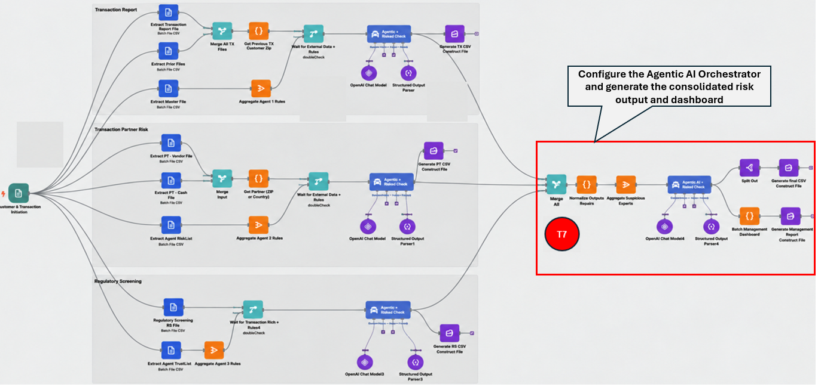

Task 7 | Build the Agent-4 Orchestration, R4 Report, and Management Dashboard
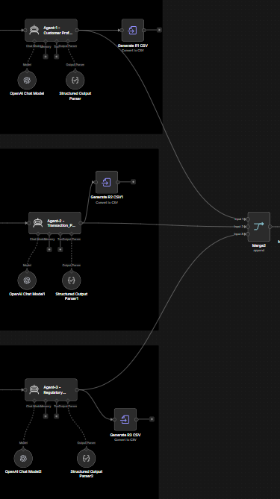
In this task, you will combine the outputs from Agent-1, Agent-2, and Agent-3, normalize and aggregate the specialist reports, configure Agent-4 as the orchestration agent, and generate both the R4 CSV report and the Management Risk Dashboard.
Step 1: Merge the specialist reports
- Add a Merge node and rename it Merge Specialist Reports.
Set Mode: Append.
- Set Number of Inputs: 3.
- To combine the specialist outputs into one stream, connect the outputs from the three specialist branches as shown in the image:
Agent-1 output → Input 1
Agent-2 output → Input 2
Agent-3 output → Input 3

.Step 2: Add the Normalize Specialist Reports node
The purpose of this step is to make sure Agent-1, Agent-2, and Agent-3 reports follow a consistent structure.
- Add a Code node after the Merge node.
- Rename it Normalize Specialist Reports.
- Connect: Merge Specialist Reports → Normalize Specialist Reports.
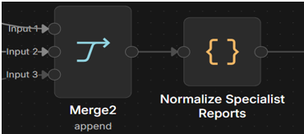
- Use this node to standardize the specialist output fields before they are passed to Agent-4.
Step 3: Aggregate the specialist reports
- Add an Aggregate node after the Normalize node.
- Rename it Aggregate Specialist Reports.
- Connect: Normalize Specialist Reports → Aggregate Specialist Reports.
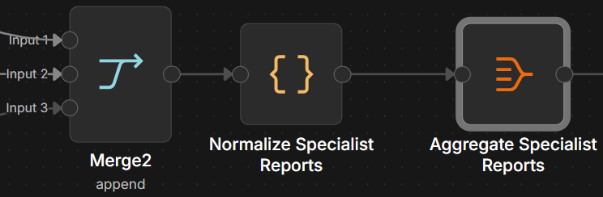
- Configure the Aggregate node to collect all specialist report items into a single list.
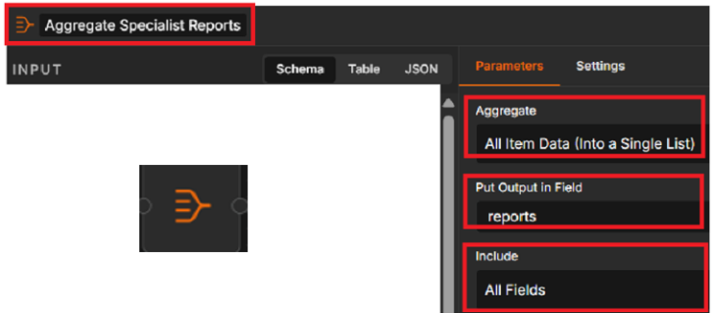
- To create one array of reports containing all current specialist assessments. Set Put Output in Field reports as shown.

Step 4: Add and configure Agent-4
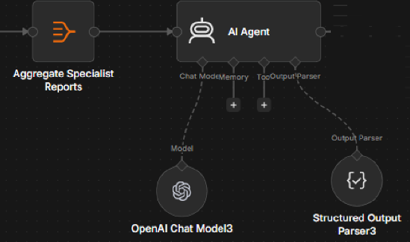
- Add an AI Agent node after the Aggregate node.
- Rename it Agent-4 - Agentic AI Orchestrator.
- Set
- Source of Prompt: Define below
- Require Specific Output Format: ON
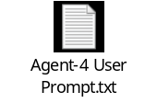 | 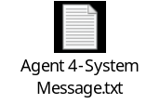

- Connect: Aggregate Specialist Reports → Agent-4.
- Connect an OpenAI Chat Model to the Chat Model port.
- Keep the model configuration consistent with the earlier agents.
- Set Model: gpt-4o-mini and Sampling Temperature: 0.0
Step 5: Configure the Structured Output Parser
- Open the Structured Output Parser connected to Agent-4.
- Connect a Structured Output Parser to the Output Parser port.
- Set Schema Type: Generate From JSON Example and use the provided JSON script.
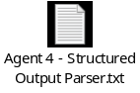
Step 6: Generate the R4 CSV report
- Add a Split-Out node after Agent-4.
Set Fields To Split Out: output.R4 and Include: No Other Fields
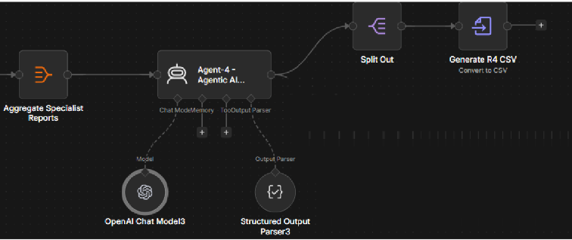
- Connect: Agent-4 → Split Out.
- Add a Convert to File node after Split Out.
Rename it Generate R4 CSV.
Set
- Operation: Convert to CSV.
- Put Output File in Field: data
- File name to: R4_Agentic_AI_Recommendation.csv

Step 7: Build the Management Dashboard

- From the main output of Agent-4, add a Code node . and connect it directly to Agent-4.
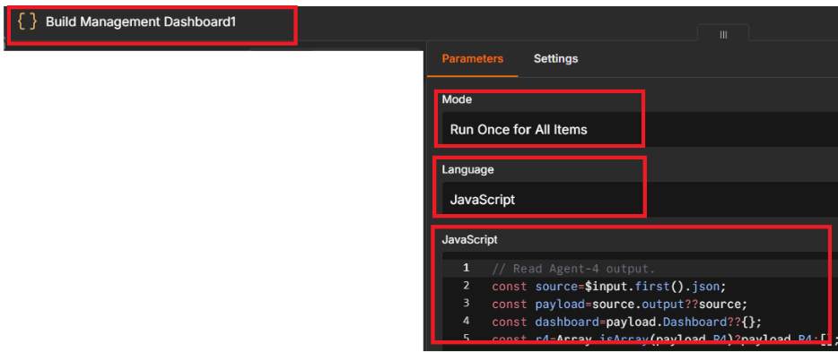
- Rename it Build Management Dashboard. Use this node to calculate the management metrics from the current R4 data.
- Set
- mode as Run Once for All Items
- Language: JavaScript
- JavaScript: 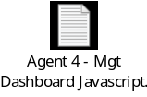

- Add a Convert to Text File node after the dashboard Code node.
- Rename it Generate Management SVG.
Connect: Build Management Dashboard → Generate Management SVG.

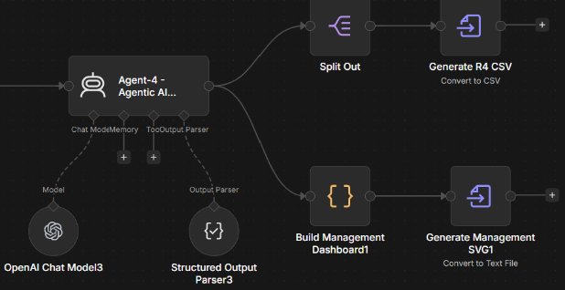
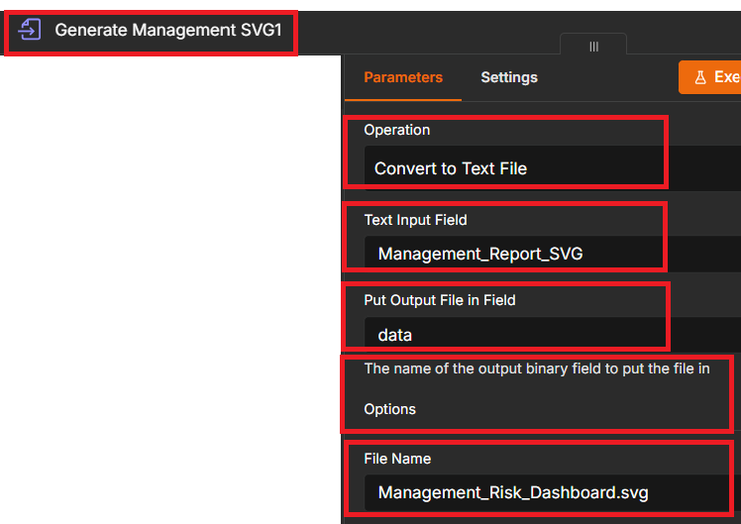
- Operation: Convert to Text File
- Text Input Field: Management_Report.svg
- Put Output File in Field: data
- File Name: Management_Risk_Dashboard.svg

Step 8: Test the workflow
- Click the  button at the bottom of the screen to run and test the complete workflow.

Task 7: Expected Output

Task 7 is complete when Agent-1, Agent-2, and Agent-3 outputs are combined and evaluated by Agent-4, producing both the R4_Agentic_AI_Recommendation.csv report and the Management_Risk_Dashboard.svg file, as shown in the workflow image.
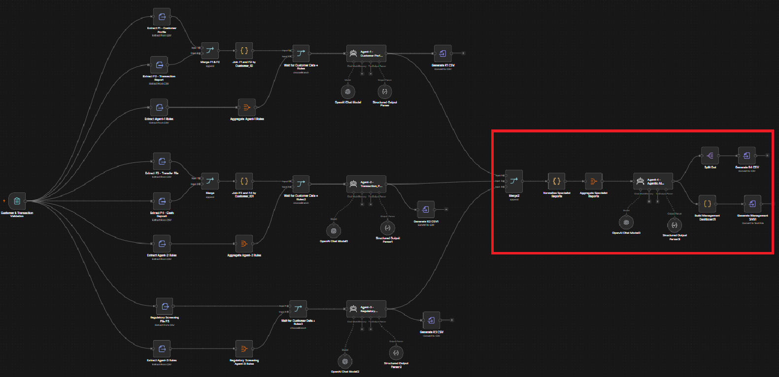
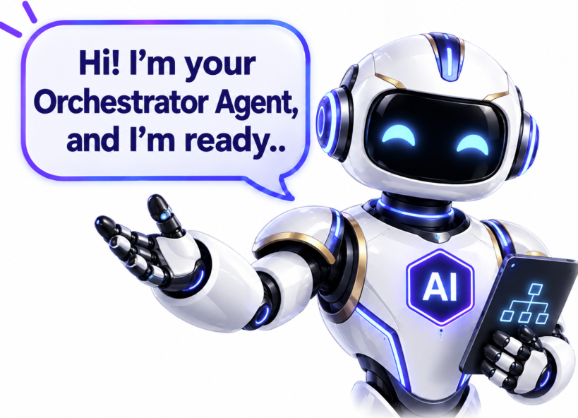
Please update your Answer document

Thank You

